June 2019

**Labeling Guidelines**

|  |  |  |  |
| --- | --- | --- | --- |
| **Domain relevance**  *Relevance for our domain “organic food”* | **Entity**  *The subject of the sentence* | **Sentiment**  *The opinion regarding the subject/its characteristics* | **Attribute**  *The characteristics of the subject* |
| In-domain | Organic  →*most important entity = our domain* | Positive | Price |
| Out-of-domain | Conventional | Negative | Quality-Taste-Nutrients-Appearance |
|  | GMO | Neutral-no-sentiment | Health-Safety |
|  | Local |  | Environment-Animals-Productivity |
|  |  |  | Trust-Origin |
|  |  |  | General |

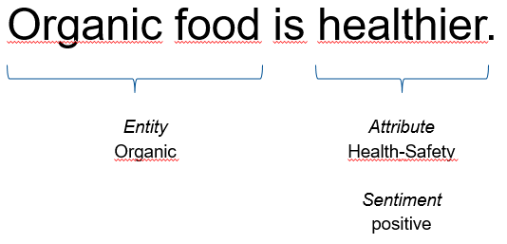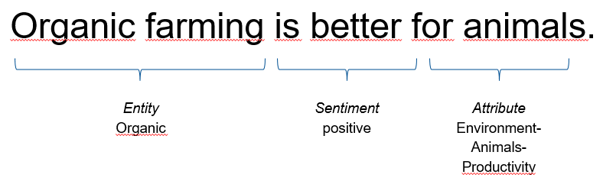

**Labeling procedure**

1. Is the sentence about our domain, i.e., organic food? Or does it mention organic in relation to one of its counterpart (conventional food, GMO-food, local food)?

→relevance: in-domain

1. Looking at the entire sentence, identify the entity/ies and the respective overall sentiment (i.e., does the person say something positive or negative or neutral regarding organic). Choose all applicable entity-sentiment pairs. Avoid labeling more than one sentiment per entity.

→most important entity-sentiment pairs:

organic-positive OR organic-negative OR organic-neutral

→further entity-sentiment pairs:

conventional-positive OR conventional-negative OR conventional-neutral

GMO-positive OR GMO-negative OR GMO-neutral

local-positive OR local-negative OR local-neutral

1. How are the entity(ies) and sentiment(s) characterized? Label all applicable attributes.

→attributes: Price, Quality-Taste-Nutrients-Appearance, Environment-Animals-Productivity, Trust-Origin, General (not characterized)

Some simple rules

* **Sentences phrased as questions** are to be labeled with neutral sentiment, e.g. “Is organic the better choice?” This does not apply if indicated otherwise, e.g. due to irony, e.g., “Who is stupid enough to pay more for organic?”
* **Do simple co-reference resolution!** We randomly selected comments (instead of single sentences) to retain the context of a sentence. Please label as follows, considering the context.
  + Sentence: Organic is definitely the better choice. →organic-positive, general
  + Subsequent sentence: It is definitely worth its price. →organic-positive, price

|  |  |  |  |
| --- | --- | --- | --- |
| **Domain relevance**  *Relevance for our domain “organic food”* | **Entity**  *The subject of the sentence* | **Sentiment**  *The opinion regarding the subject/its characteristics* | **Attribute**  *The characteristics of the subject* |
| **In-domain**  Organic food tastes good.  *→The sentence (actually the entity) is related to organic food/farming/shops/companies/brands…* | **Organic**  Organic food/ farming/agriculture  farmers/farms  shops/companies  The organic market  People buying organic | **Positive**  Organic food is better.  Organic preserves the environment. | **Price**  Organic food is expensive. |
| **Out-of-domain**  I don’t like apples.  *→Not related to organic food.* | **Conventional**  Conventional food  farming/agriculture  farmers/farms  shops/companies  The conventional market  People buying conventional  *→Users refer to “conventional” differentiating it from “organic”. →They will not always literally/directly refer to “conventional food”.*  *They say:*  *“I don’t like organic; I just go for the normal food.*  *“I don’t like the poisoned stuff they sell at Walmart”.* | **Negative**  Organic is not healthier.  Organic is far too expensive. | **Quality-Taste-Nutrients-Appearance**  Organic food is fresh / nutritious / tastes good / looks ugly. |
|  | **GMO**  GMOs  GMs/GM-food  Genetic engineering  *→The organic regulations do not allow GMOs. In the US, many people choose organic to avoid GMOs.* | **Neutral-no-sentiment**  You can buy organic at Aldi‘s.  I am not sure what to think of organic food. | **Health-Safety**  Organic food is healthy/safe/free of pesticides.  Pesticides are bad for my body.  GMO-food makes me sick. |
|  | **Local**  Local/Regional food  Food from the local farmer/my own garden |  | **Environment-Animals-Productivity**  Conventional agriculture harms the environment; it uses chemicals.  Pesticides are bad for the environment.  Organic farmers follow higher animal welfare standards.  Organic farming is not productive enough to feed the world. |
|  |  |  | **Trust-Origin**  I don’t trust organic.  Not everything labeled organic is organic.  Whether I trust organic food depends on where it comes from (which supermarket, which brand, which country/region of origin).  Where can I find organic food?  *→Whether organic food/the organic industry can be trusted, on what it depends.*  *Where to buy.* |
|  |  |  | **General**  Organic food is better.  *→Attribute not specified. No attribute mentioned. →try to avoid this label. Label only if no other attribute applies*  *E.g., organic food is considered better, yet we don’t know based on which attribute the judgement is made* |